**DAILY ONLINE ACTIVITIES SUMMARY**

|  |  |  |  |  |  |  |  |  |
| --- | --- | --- | --- | --- | --- | --- | --- | --- |
| **Date:** | **28-07-2020** | | | | | **Name:** | **Preethi** | |
| **Sem & Sec** | **6th - B** | | | | | **USN:** | **4AL17CS065** | |
| **Online Test Summary** | | | | | | | | |
| **Subject** | | **Operation Research** | | | | | | |
| **Max. Marks** | | **-** | | **Score** | | | **-** | |
| **Certification Course Summary** | | | | | | | | |
| **Course** | Python-Programming for Everybody | | | | | | | |
| **Certificate Provider** | | | **Coursera** | | **Duration** | | | **19 hrs** |
| **Coding Challenges** | | | | | | | | |
| **Problem Statement: 1 python program** | | | | | | | | |
| **Status: executed** | | | | | | | | |
| **Uploaded the report in GitHub** | | | | | **Yes** | | | |
| **If yes Repository name** | | | | | <https://github.com/PreethiNayak/Daily-Status/tree/master/28July2020> | | | |
| **Uploaded the report in slack** | | | | | **Yes** | | | |

Online Certification Course Details:-

Today I completed 1 lesson in “Python-Programming for everybody” Course.

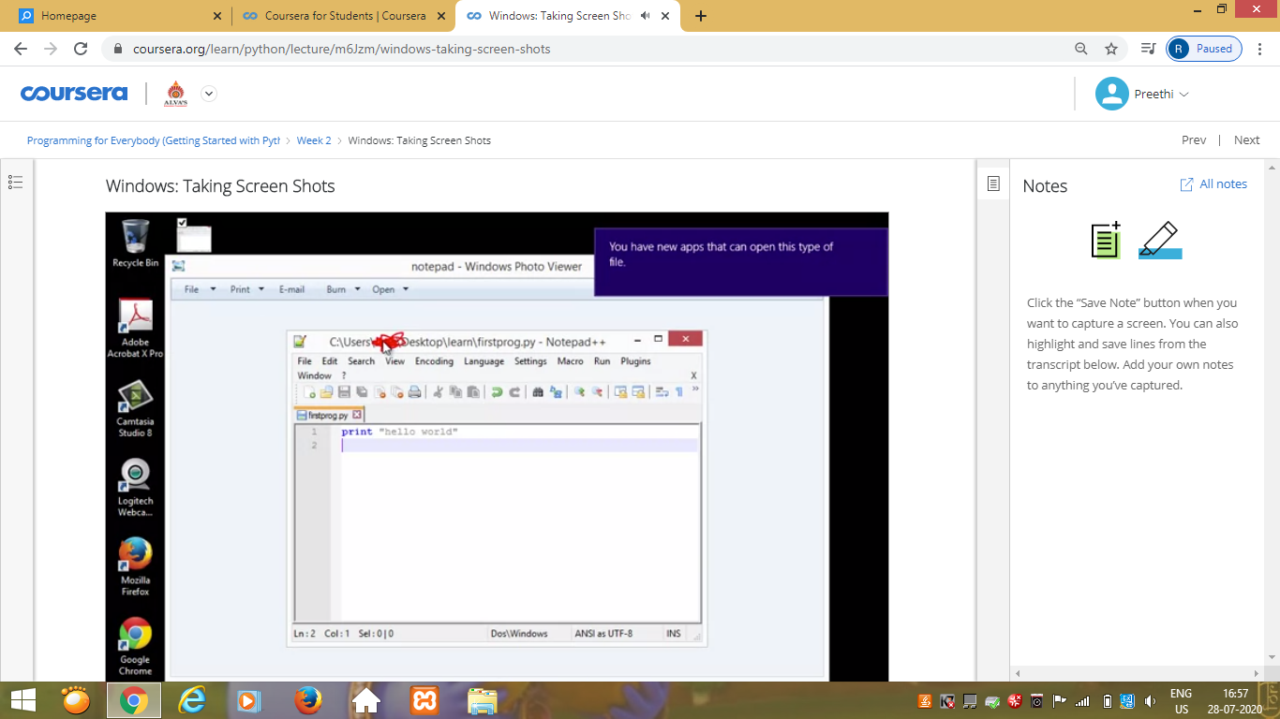

Coding Challenges Details: (Attach the snapshot and briefly write the report for the same)

Program 1

This is output of python program for Smallest K digit number divisible by X.

